**ABSTRACT**

In the car wash scenario, the queue data structure provides a useful solution for organizing the customer service process. The queue follows the "first-in, first-out" (FIFO) principle, meaning that customers who arrive first are serviced first, and subsequent customers are serviced in the order in which they arrive. By using a queue, the car wash can ensure that each customer receives fair and efficient service, without any confusion or disputes about who should be serviced next.The implementation of a queue data structure in a car wash can be achieved through computer programming, allowing for real-time monitoring and management of the customer queue. This can help to optimize the car wash process and ensure that all customers receive high-quality service in a timely manner.In addition to providing an organized and efficient service process, the use of a queue data structure can also help to improve customer satisfaction. Customers are able to join the queue and be serviced in a predictable and fair manner, without any delays or confusion. This can help to build trust and confidence in the car wash service, leading to increased customer loyalty and repeat business.Overall, the use of a queue data structure in a car wash provides a useful solution for organizing and optimizing the customer service process. By implementing a queue, the car wash can ensure fair and efficient service for all customers, while also improving customer satisfaction and building trust in the service.

**TABLE OF CONTENTS**

Title Page No.

**Abstract----------------------------------------------------------------------------------i**

**Chapter 1: Introduction--------------------------------------------------------------1**

1.1Introduction-------------------------------------------------------------1

1.2 Statement of the problem-------------------------------------------- 1

1.3 Objectives---------------------------------------------------------------1

1.4 Applications------------------------------------------------------------2

1.5 Limitations-------------------------------------------------------------3

**Chapter 2: Design-------------------------------------------------------------------10**

2.1 Requirements---------------------------------------------------------4

2.2 System Design--------------------------------------------------------6

**Chapter 3: Coding and Result---------------------------------------------------17**

3.1 Code------------------------------------------------------------------11

3.2 Result----------------------------------------------------------------14

**Chapter 4 Conclusion and Future work--------------------------------------19**

4.1 Conclusion----------------------------------------------------------18

4.2 Future work--------------------------------------------------------19

**CHAPTER 1 INTRODUCTION**

* 1. **Introduction**

A car wash is a common scenario where the concept of a queue data structure can be applied. In a queue, the customer who arrives first is serviced first, and subsequent customers are serviced in the order in which they arrive. This is known as the "first-in, first-out" (FIFO) principle. In a car wash, customers arrive at the car wash with their vehicles and join the end of the queue. As each car is serviced, it moves to the front of the queue and is washed.

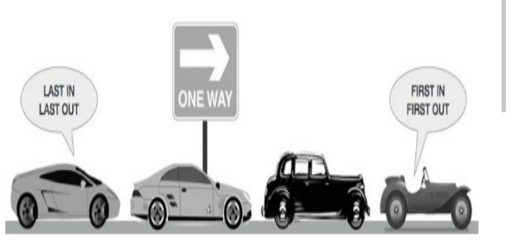The car wash operates continuously, with cars entering and leaving the queue as they are washed.By using a queue data structure, the car wash can ensure that each customer is serviced in the order in which they arrived, without any confusion or disputes about who should be serviced next. This helps to maintain an organized and efficient car washing process.

**Problem Statement:**

Implement queue for a car wash line (FIFO).

**1.3 Objectives:**

1. To be viewed as a best car wash in our area.

2. Provide outstanding customer service and competitive pricing.

**1.4 Applications:**

**➢Customer Service:** By using a queue system, customers can be served on a firstcome, first-served basis. This helps to ensure that all customers are treated fairly and reduces the risk of disputes over who should be served next.

**Efficiency:** Queues can help to streamline the process of washing cars by ensuring that each vehicle is washed in the correct order. This helps to reduce the risk of bottlenecks and improves the overall efficiency of the car wash line.

➢ **Staff Management:** Queues can help to manage the flow of cars through the car wash, reducing the need for staff to be constantly monitoring the line. This allows staff to focus on other tasks, such as cleaning and maintaining the equipment.

➢ **Wait Time Management:** Queues can help to manage customer wait times by providing an accurate estimate of the time it will take for each car to be washed. This information can be displayed on screens or communicated to customers in other ways, helping to manage customer expectations and reduce frustration.

➢ **Data Collection:** Queues can also be used to collect data on customer behavior and preferences, which can be used to improve the overall customer experience and to optimize the car wash line for maximum efficiency.

**1.5 Limitations:**

➢ **Unpredictable wait times:** Queues are often subject to fluctuations in demand and other unpredictable factors, which can result in long wait times for customers.

➢ **Limited capacity:** Queues have a limited capacity, and when demand exceeds the capacity of the queue, customers may be turned away or forced to wait for an extended period of time.

**➢ Inefficient use of resources**: Queues can be inefficient, as they may result in idle time for service providers or employees during periods of low demand, while during periods of high demand they may be unable to keep up with demand.

**➢ Customer dissatisfaction:** Long wait times and limited capacity can result in customer dissatisfaction, leading to a negative experience for customers and potentially harm to the reputation of the business.

➢ **Inability to prioritize customers:** Queues may not have the ability to prioritize customers based on their needs or the type of service they require, leading to a one size-fits-all approach that may not meet the needs of all customers. **CHAPTER-2**

**DESIGN**

**2.1 Requirements:**

**Software Requirements:**

|  |
| --- |
|  |
|  |  |

***Fig:1***

The requirements for the car wash line management system using an array are as follows:

**1.Array data structure:** The system should use an array data structure to represent the line of cars waiting to be washed.

**2.Adding cars to the line:** The system should allow for the efficient addition of cars to the end of the line.

**3.Removing cars from the line:** The system should allow for the efficient removal of cars from the front of the line

#### 

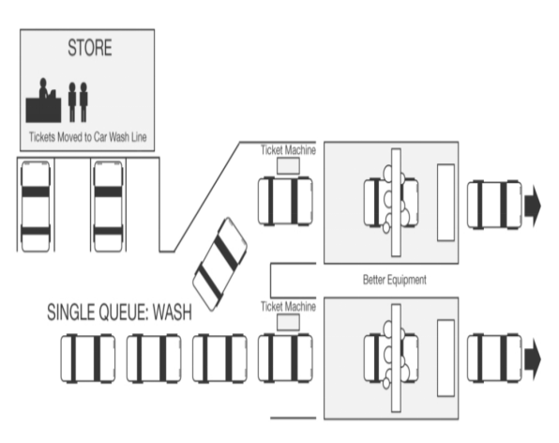

|  |
| --- |
|  |
|  |  |

***Fig:2***

**4.Line status:** The system should provide real-time information about the status of the line, including the number of cars waiting and their order.

**5.Reordering cars:** The system should allow for the reordering of cars within the line, such as moving a car from the end to the front.

**6.Scalability:** The system should be scalable and able to handle an arbitrary number of cars in the line.

**7.Data storage:** The system should be able to persist data about the cars in the line and their positions, even after the program is closed.

**8.Performance:** The system should be efficient and have a fast response time, even with a large number of cars in the line.

**9.User interface:** The system should have a user-friendly interface that allows for easy interaction with the system

**System Design:**

The following is a high-level system design for a car wash line using arrays:

**1.Data Structure:** The system will use an array data structure to store and manage the order of cars in the line. The array will have a fixed size, and each element will represent carin thline. The first element in the array will be the next car in line to be washed.

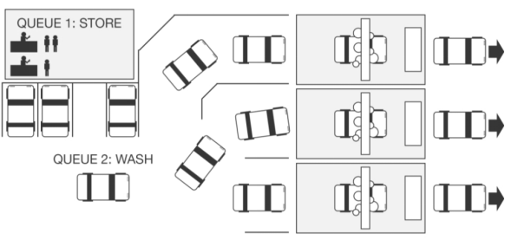

***Fig:3***

**2.User input:** The system will provide a way for users to add or remove cars from the line. This could be done through a user interface, such as a command-line interface or a graphical user interface.

**3.Display of Line Status:** The system will provide a way to display the status of the line, such as the number of cars in the line and the next car in line to be washed. This information could be displayed on the user interface or printed to the console.

**4.Queue Operations:** The system will provide operations for managing the order of cars in the line, such as adding a car to the end of the line, removing the next car in line, and displaying the status of the line.

**5.Scalability:** The system should be scalable, allowing for an arbitrary number of cars to be added to the line. This could be achieved by dynamically allocating more memory for the array as needed.

**6.Security:** The system should have appropriate security measures in place, such as input validation and user authentication, to prevent unauthorized access and data tampering.

**2.3 UML DIAGRAMS**

**CLASS DIAGRAM**

A class diagram is a type of UML diagram that provides a visual representation of the classes in a software system, along with their attributes, methods, and the relationships between them. A class is a blueprint for creating objects, and it defines the properties and behaviors of the objects that are created from it. The relationships between classes can be association, aggregation, composition, generalization, or realization, and they help to illustrate the interactions between the various classes in the system. Class diagrams are useful for designing, documenting, and communicating software systems, and they can be used to generate code or analyze the structure of existing systems.

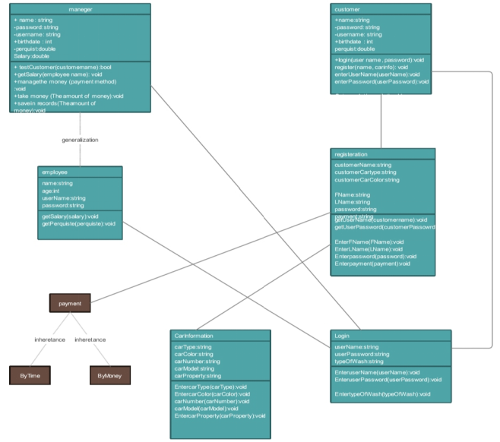

**USE- CASE DIAGRAM**

A use case diagram is a type of UML (Unified Modeling Language) diagram that represents the interactions between actors and a system to achieve a specific goal or task. It shows the actors, use cases, and relationships between them. Actors are external entities that interact with the system, and use cases are the specific tasks or actions that the system can perform. It is a useful tool for visualizing and designing the requirements and functionality of a software system.An actor is an external entity that interacts with the system to accomplish a task. An actor can be a person, another system, or an organization. Actors are represented by stick figures in a use case diagram.A use case represents a specific task or action that the system can perform. It describes what the system does to provide value to its actors. A use case is represented by an oval shape in a use case diagram, and it is labeled with a verb-noun phrase that describes the action it represents.

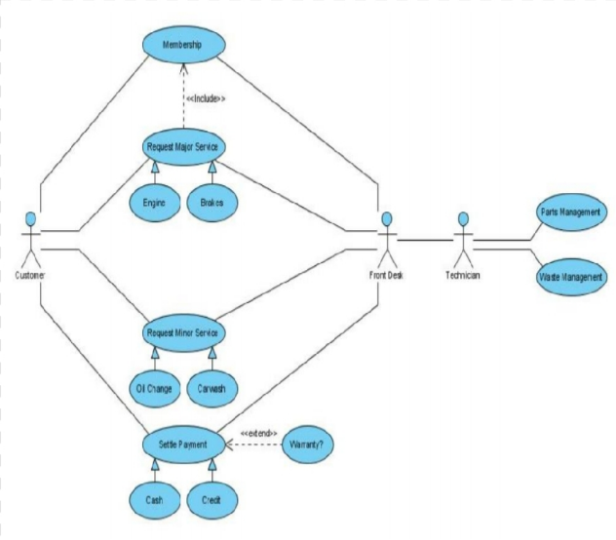

**ACTIVITY DIAGRAM**

An activity diagram is a type of UML (Unified Modeling Language) diagram that represents the flow of activities and actions in a process or system. It shows the steps, decisions, and actions involved in a process, and it can be used to model both high-level business processes and low-level software processes. It is a useful tool for visualizing and designing the behavior of a system.Activity diagrams can also show concurrency and synchronization of activities. Concurrency is represented by a fork, which allows multiple activities to occur in parallel, and a join, which brings the parallel activities back together. Synchronization is represented by a merge, which combines the flows of two or more activities.

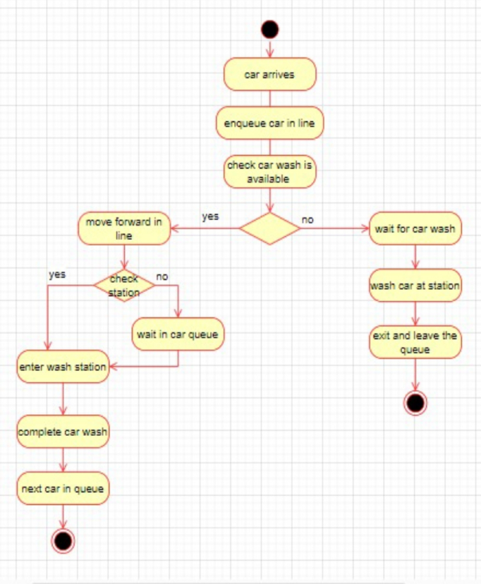

**FLOW CHART**

A flowchart is a graphical representation of a process or system, typically using symbols and arrows to depict the various steps or activities and their sequence. It is used to visualize the flow of a process, decision points, and the possible outcomes of each decision.A typical flowchart includes a starting point, represented by a circle or oval, and an ending point, represented by a rectangle with rounded corners.

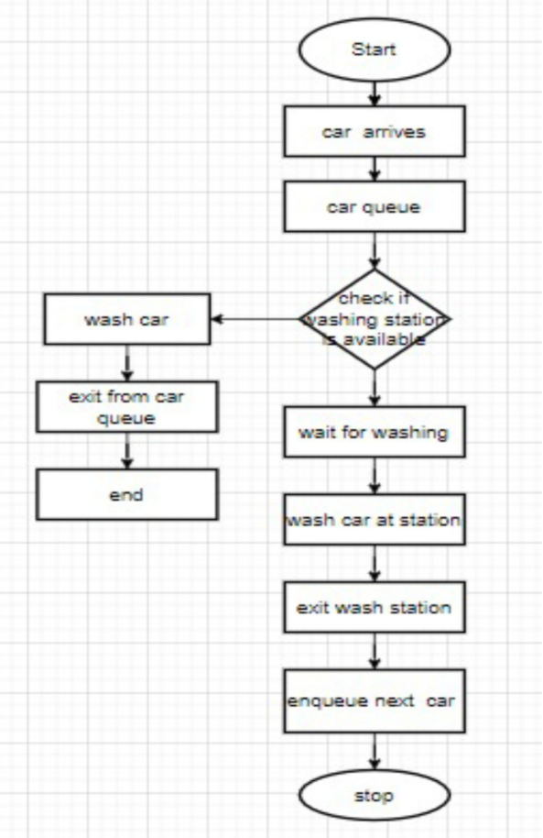

**CHAPTER-3**

**CODING AND RESULTS**

**Code & Result:**

#include <stdio.h>

#include <stdlib.h>

#define MAX_QUEUE_SIZE 10

int car_wash_queue[MAX_QUEUE_SIZE];

int front = -1, rear = -1;

void enqueue(int car_number) {

if (rear == MAX_QUEUE_SIZE - 1) {

printf("Car Queue is full!\n");

} else {

if (front == -1) {

front = 0;

}

rear++;

car_wash_queue[rear] = car_number;

printf("Car No: %d added to the queue.\n", car_number);

}

}

void dequeue() {

if (front == -1) {

printf(" Car Queue is empty!\n");

} else {

printf("Car No:%d is being washed.\n", car_wash_queue[front]);

front++;

if (front > rear) {

front = rear = -1;

}

}}

void display() {

if (front == -1) {

printf(" Car Queue is empty!\n");

} else {

printf("Cars waiting in the queue:\n");

for (int i = front; i <= rear; i++) {

printf("%d ", car_wash_queue[i]);

}

printf("\n");

}}

int main() {

int choice, car_number;

while (1) {

printf("\n*******************Car Wash Line******************\n");

printf("\n==========================================\n");

printf("1. Add car to the queue\n");

printf("2. Wash car\n");

printf("3. Display queue\n");

printf("4. Exit\n");

printf("Enter your choice: ");

scanf("%d", &choice);

switch (choice) {

case 1:

printf("Enter car number: ");

scanf("%d", &car_number);

enqueue(car_number);

break;

case 2:

dequeue();

break;

case 3:

display();

break;

case 4:

exit(0);

default:

printf("Invalid choice!\n");

}

}

return 0;

}

**Result:**

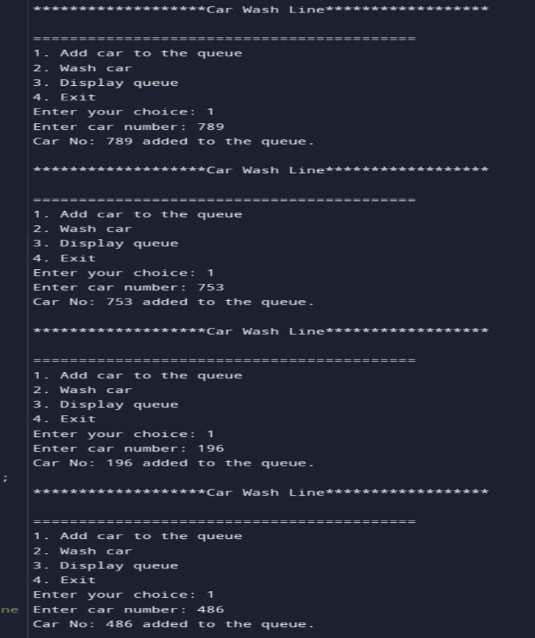

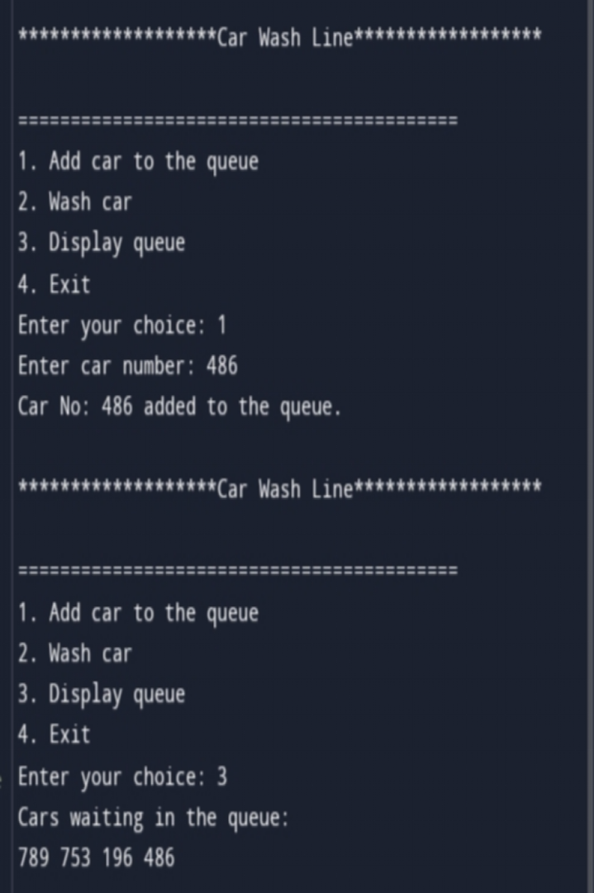

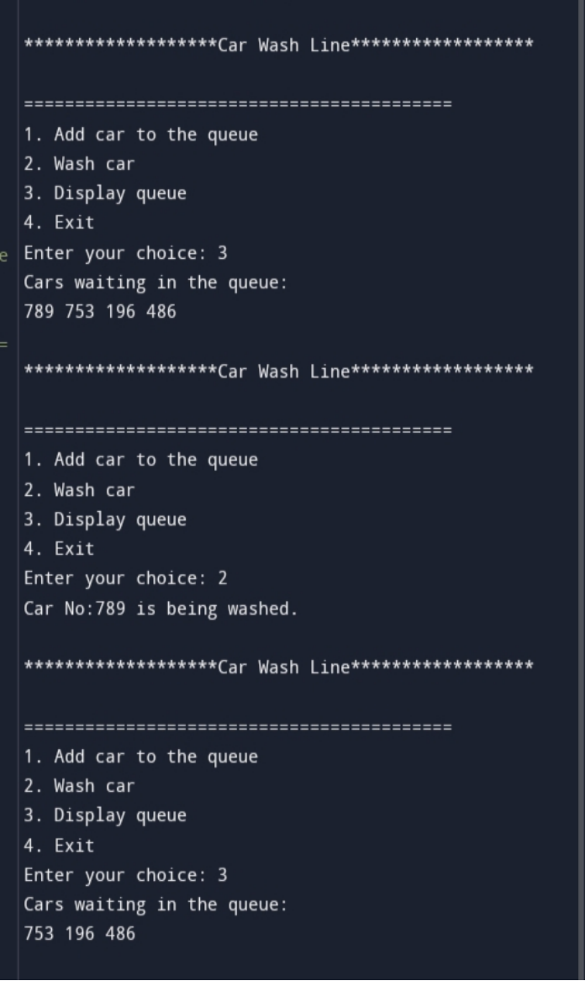

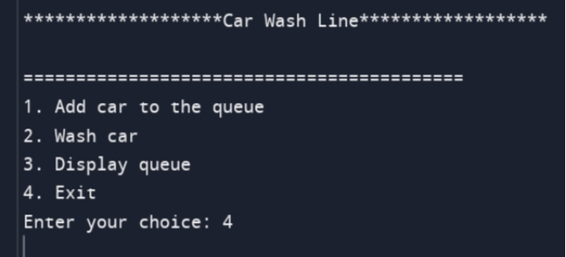

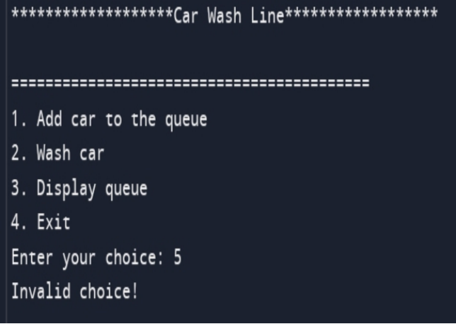

**CONCLUSION AND FUTURE WORK**

**4.1 Conclusion**

The car wash queue system using arrays is a simple and effective solution for managing the order of cars waiting to be washed. It allows the system to keep track of the cars in the queue and provide the next car in line to be washed.

This solution can be further improved by adding additional features such as the ability to serve multiple cars at the same time, a user interface for customers to view the status of the line, a database to store information about the cars in the line, and integration with a payment system. These additions would enhance the system's functionality and provide a better experience for both customers and car wash operator.

The use of an array data structure in a car wash line can provide a number of benefits in terms of efficiency, functionality, and data management. By analyzing the data stored in the array and using it to optimize various aspects of the car wash process, businesses can improve the quality and speed of their service, as well as gain a better understanding of their customer base and traffic patterns. Furthermore, by using more advanced technologies such as machine learning or cloud-based solutions, the array can be leveraged even further to generate insights and automate various tasks. Overall, the use of an array in a car wash line is a valuable tool for businesses looking to improve their operations and stay competitive in an increasingly data-driven market.

Overall, the car wash queue system using arrays is a good foundation for building a more complex and feature-rich system. By incorporating the suggested improvements, the system can provide an even better experience for both customers and car wash operators.

**4.2 Future Work:**

There are several potential areas of future work for a car wash line queue implemented using an array. Here are a few:

**1.Optimization:** Depending on the specific use case, there may be opportunities to optimize the implementation of the queue. For example, it may be possible to reduce the time complexity of certain operations or to use memory more efficiently.

**2.Tracking:** You could use the array data to track the progress of each car through the wash process, and use that information to provide real-time updates to customers.

**3.Automation:** You could use the array data to automate certain parts of the wash process. For example, you could use sensors to detect when a car has entered a particular point in the array, and use that information to trigger the start of a particular wash cycle.

**4.Expansion:** If your car wash business is successful and you decide to expand, you could use the array data to design more efficient and effective layouts for new wash locations.

**5.Mobile app integration:** Customers could use a mobile app to join the queue remotely, allowing them to avoid waiting in line. The app could also provide real-time updates on the wait time, allowing customers to make more informed decisions about when to arrive at the car wash.

**6.Automated payment:** Automated payment systems could be integrated into the car wash process, allowing customers to pay for their wash without having to leave their car. This would streamline the payment process and reduce the time spent waiting in line.

**7.Smart bays:** Car wash bays could become "smart," using sensors and other technologies to monitor their usage and optimize the flow of cars through the wash line. For example, if a wash bay is free, the next car in the queue could be automatically directed to that bay, reducing wait times.

**8.Remote monitoring and control:** Car wash operators could use remote monitoring and control systems to monitor the wash line in real-time, making adjustments as needed to optimize the flow of cars and reduce wait times.

Overall, the use of an array to manage a car wash line offers a lot of potential for optimization and automation, which could help improve customer satisfaction and increase revenue.